Villers-Bocage
8
MILITARY

2ND BRIT
AIR POWER
Jabos: 2 x 1st BRIT Army
RESOURCES
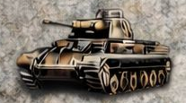
1st SS Pz

ORDERS: 3 Actions
-1 Defense Strength US 1st ARMY
-1 Defense Strength BRIT 2nd ARMY
-1 Defense Strength CAN 1st ARMY
The battle of Villers-Bocage was the result of a British attempt to improve their position by exploiting a temporary vulnerability in the German defences to the west of the city of Caen.The British withdrawal marked the end of the post D-Day "scramble for ground" and the start of a grinding attritional battle for Caen

